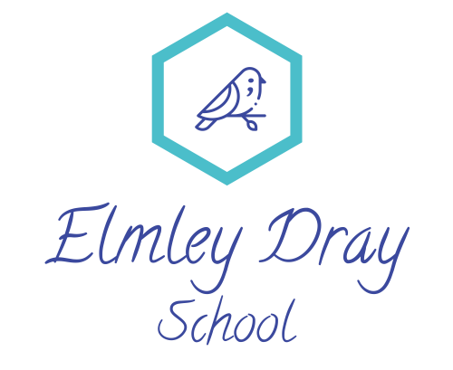

Elmley Dray School Admissions Policy

This admissions policy relates to our Independent SEND full time school admissions for children aged 9-19. The school can meet the needs of the following designated need types:
- Autism or Autism traits including Sensory Needs
- Communication and Interaction
- Emotional and Mental Health (Anxiety, Depression and Adjustment Disorder based)
- FASD
- ADHD

The age group of learners are:
- Key Stage 2 for Year 5 and 6 (from age 9 years)
- Key Stage 3 for Year 7 to Year 9
- Key Stage 4 for Year 9 onwards
- Key Stage 5 for Year 12 onwards (to age 19)

Students will be expected to be able to work towards either a life skills curriculum, entry level, level 1, level 2, and GCSE qualifications by the end of Key Stage 4 or 5.

There is a holistic approach to personal and social development, emotional wellbeing and resilience and learning outside of the classroom.
Admission arrangements
Learners become known to the school as prospective pupils via a number of routes:
Informal enquiries from parents/carers – Parents/carers are welcome to phone or visit the school in order to help them decide on the type of special school provision that may be suitable, and that they may prefer, for their child. All are advised however that if they wish to formally request a placement, this must be done through the Local Authority.
Formal Requests from the Local Authority - Consultations are sent directly to the school for consideration. Wherever possible, the school would prefer to meet a learner prior to considering his or her suitability for placement, i.e. as well as reading reports, assessments, etc. This can be achieved either by the learner visiting the school or by a member of the Leadership Team visiting the pupil in their current placement, or in their home. All requests for, or expressions of interest in, placements are recorded by the school. No offer of a place can be made until an official referral has been sent to the school through the Local Authority. These are then considered by the Headteacher. The Headteacher will then advise Local Authority as to whether the school is suitable and also whether there are any places available. The decision of the school may result in further discussion with the Local Authority.
Once an admission has been formally agreed with the Local Authority, a letter of confirmation will be written by the LA to the learner’s parents/carers. This is closely followed by an admission pack from the school including a set of admission and consent forms for parents/carers to complete and return to the school. Parents/carers are required to bring an original copy of the learner’s birth certificate and confirmation of address to the school office prior to admission. Parents/carers and their child will be invited to an admission meeting prior to enrolment, where there will be a chance to meet the staff who will be working with your child, hear about the school and expectations, and visit the classroom where the child will be based.
Version control - Approval and review

Version No. | Approved By | Approval Date | Main Change | Review Period
1 | Hayley Furnell | October 2024 | Initial policy approved | Annually
1.1 | Hayley Furnell | August 2025 | Annual review, removal of requirement to be within 2 academic years of ability | Annually

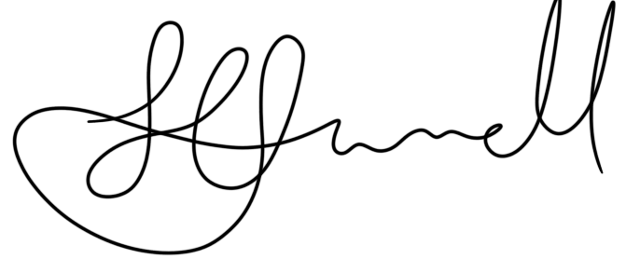
Hayley Furnell, Director,
on behalf of Elmley Dray School
Dated: August 2025
Next review: August 2026

